**WYSIWYG editor**

After adding the required webpages and managing their hierarchy in the sitemap, you can add various components. The WYSIWYG (What You See Is What You Get) editor allows you to add and edit the required components on the canvas easily. You can add and edit the following components on the canvas:

* [Sections](https://docs.microsoft.com/en-us/powerapps/maker/portals/add-sections)
  + - One column section
    - Two columns section
    - Three columns section
* Components
  + - [Text](https://docs.microsoft.com/en-us/powerapps/maker/portals/add-text)
    - [Image](https://docs.microsoft.com/en-us/powerapps/maker/portals/add-image)
    - [IFrame](https://docs.microsoft.com/en-us/powerapps/maker/portals/add-iframe)
    - [Form](https://docs.microsoft.com/en-us/powerapps/maker/portals/add-form)
    - [List](https://docs.microsoft.com/en-us/powerapps/maker/portals/add-list)
    - [Breadcrumb](https://docs.microsoft.com/en-us/powerapps/maker/portals/add-breadcrumb)
    - [Custom menu](https://docs.microsoft.com/en-us/powerapps/maker/portals/add-custom-menu)
    - [Use code editor](https://docs.microsoft.com/en-us/powerapps/maker/portals/use-code-editor)
    - [Power BI](https://docs.microsoft.com/en-us/powerapps/maker/portals/add-powerbi)

To use the WYSIWYG editor:

1. [Edit the portal](https://docs.microsoft.com/en-us/powerapps/maker/portals/manage-existing-portals#edit) to open it in Power Apps portals Studio.
2. Select the page on which you want to add the component.
3. Select an editable element on the canvas.

**Note**

The editable elements are demarcated by a boundary.

1. Select **Components** components icon. from the left side of the screen.
2. Select the component to be added.

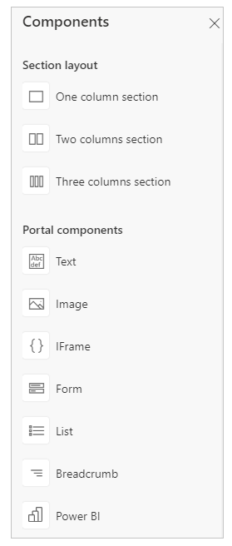

The selected component is added to the canvas inside the editable element.

1. To delete a component, select the component on the canvas and then select **Delete** on the command bar at the top of the page.

delete component.

# Add sections

Sections allow you to define a structure for your page and arrange portal components. Once you add sections to your page, you can add portal components inside the sections as per the requirement.

To add sections:

1. [Edit the portal](https://docs.microsoft.com/en-us/powerapps/maker/portals/manage-existing-portals#edit) to open it in Power Apps portals Studio.
2. Select the page on which you want to add a section.
3. Select an editable element on the canvas.
4. Select **Components** components icon. from left side of the screen.
5. Under **Section layout**, select the section type to be inserted.
6. In the properties pane on the right side of the screen, enter or select the following information:
   * **Min Height**: Enter the minimum height of the section. If you add a component that occupies more space than the specified height, the section expands to accommodate the component. By default, the minimum height is 100 px. You can also enter the height in points (pt) and percentage (%).

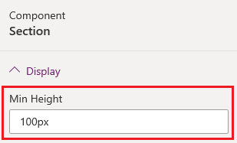

* + **Alignment**: Select whether the component in the section must be left, center, or right aligned.

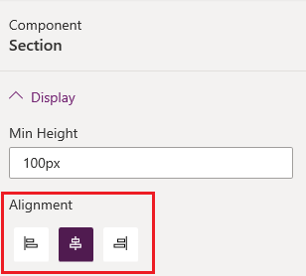

* + **Background**: Select if you'd like to have color or an image as the section background.
  + **Fill**: Select a color for the background.

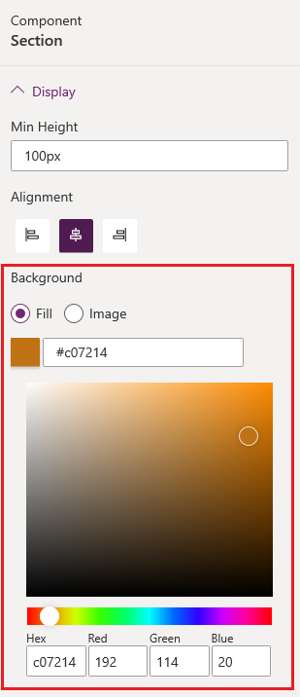

* + **Image**: Select an image from the list. If you would like to upload a new image, select **Upload image**.

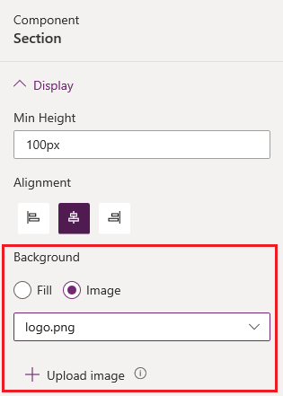

1. Add the required portal component in the section

# Add text box

 text box component allows you to add text inside your portal page.

To add text box:

1. [Edit the portal](https://docs.microsoft.com/en-us/powerapps/maker/portals/manage-existing-portals#edit) to open it in Power Apps portals Studio.
2. Select the page on which you want to add the component.
3. Select an editable element on the canvas.
4. Select **Components** components icon. from the left side of the screen.
5. Under **Portal components**, select **Text**.
6. Enter the required text in the text box.
7. To format the text, select the text to display the format options. Modify the font size and style as required.



1. In the properties pane on the right side of the screen, select the following information:
   * **Alignment**: Select whether the text must be left, center, or right aligned.
   * **Font color**: Select a color for the text.

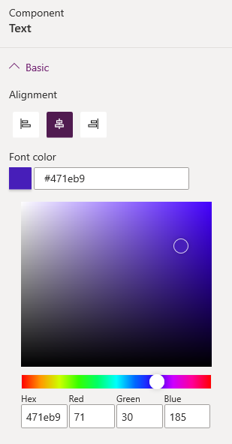

# Add image

Image component allows you to add images to your portal page.

To add image component:

1. [Edit the portal](https://docs.microsoft.com/en-us/powerapps/maker/portals/manage-existing-portals#edit) to open it in Power Apps portals Studio.
2. Select the page on which you want to add the component.
3. Select an editable element on the canvas.
4. Select **Components** components icon. from the left side of the screen.
5. Under **Portal components**, select **Image**. The image placeholder is added to the canvas.
6. In the properties pane on the right side of the screen, enter the following information:
   * **Image**: Select this option if you would like to select an existing image or upload a new one. If you want to select a previously uploaded image, choose an image from the **Select image** list. To upload a new image, select **Upload image**. All the uploaded images are included in the image library, which can be selected again through the **Select image** list.

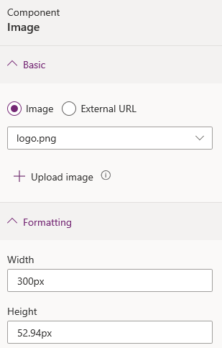

**Note**

* + - You can upload only the images of type png, svg, jpg, and jpeg with the maximum size of 5 MB.
    - You can't upload an image with the same name. You need to modify the name of the image to upload it again.
  + **External url**: Select this option if you would like to upload an image from an external URL. Enter the URL in the **External url** field. Only secured links are accepted—that is, https:// is mandatory. If you have images stored in your content delivery network, you can provide the link in this field.

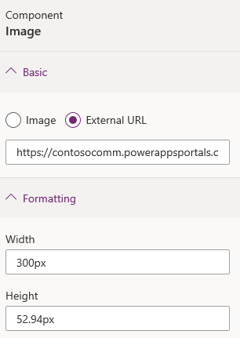

* + **Formatting options**
    - **Width**: Enter width of the image.
    - **Height**: Enter height of the image.

# Add IFrame

Add IFrame component to your portal page to embed a webpage from any other website.

To add IFrame component:

1. [Edit the portal](https://docs.microsoft.com/en-us/powerapps/maker/portals/manage-existing-portals#edit) to open it in Power Apps portals Studio.
2. Select the page on which you want to add the component.
3. Select an editable element on the canvas.
4. Select **Components** components icon. from the left side of the screen.
5. Under **Portal components**, select **IFrame**. The IFrame placeholder is added to the canvas.
6. In the properties pane on the right side of the screen, enter the following information:
   * **Width**: Enter the width of the IFrame.
   * **Height**: Enter the height of the IFrame.

**Note**

You can also select the IFrame on the canvas and drag the handles to resize it.

* + **Link**: Enter the URL of the website to be displayed in the IFrame. Only secured links are accepted—that is, https:// is mandatory. By default, [https://www.bing.com](https://www.bing.com/) is available as the value.

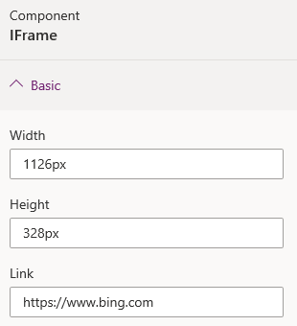

# Add form

Form is a data-driven configuration that collects data in the portal without the need for a developer to surface the form in the portal.

Forms are [created in Microsoft Dataverse](https://docs.microsoft.com/en-us/powerapps/maker/model-driven-apps/form-designer-overview). You can use them in webpages in the portal or in conjunction with lists to build out complete web applications.

To add a form component:

1. [Edit the portal](https://docs.microsoft.com/en-us/powerapps/maker/portals/manage-existing-portals#edit) to open it in Power Apps portals Studio.
2. Select the page on which you want to add the component.
3. Select an editable element on the canvas.
4. Select **Components** components icon. from the left side of the screen.
5. Under **Portal components**, select **Form**.
6. In the properties pane on the right side of the screen, select one of the following options:
   * **Create new**: Create a new form.
   * **Use existing**: Use an existing form.
7. Enter information or make selection:
   * **Name**: Name of the form.
   * **Table**: The name of the table from which the form is loaded.
   * **Form layout**: The name of the form on the target table in Dataverse that is to be rendered.
   * **Mode**: Select one of the following options:
     + **Insert**: Indicates the form should insert a new record upon submission.
     + **Edit**: Indicates the form should edit an existing record.
     + **Read only**: Indicates the form should display an existing record's non-editable form.

**Note**

The default option for **Edit** and **ReadOnly** modes is set as Query String Parameter Name passed as ID in URL. To change these values, you need to open Portal Management app and update the form properties.

* + **On success**: Select one of the following options:
    - **Show success message**: Requires a message to be displayed to the user on successful submission of the form. You can also select **Hide form on success** to hide the form upon successful submission.
    - **Redirect to webpage**: Redirects the user to the selected webpage in the portal. This field is required.
    - **Redirect to URL**: Redirects the user to the specified URL. This field is required.
  + **Show captcha for anonymous users**: Displays captcha to anonymous users.
  + **Show captcha for authenticated users**: Displays captcha to authenticated users.
  + **Permissions**: Table permissions to be considered for the form. [Configure table permissions](https://docs.microsoft.com/en-us/powerapps/maker/portals/configure/entity-permissions-studio) to make the form available to anyone, or any specific roles.

**Note**

If one or more forms/lists have no permissions configured, you'll see this warning: "One or more lists or forms on your site have no set permissions. Permissions must be enabled for all data components by April 2022 or they will be set by the system."

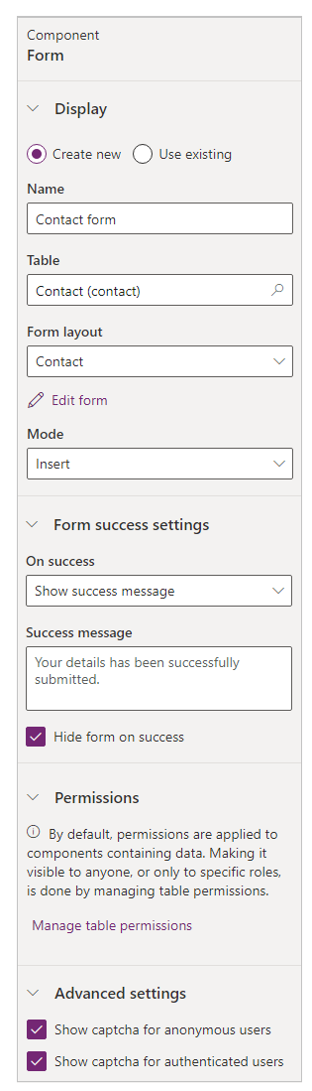

# Add list

List is a data-driven configuration to render a list of records without the need for a developer to surface the grid in the portal.

Lists use [Dataverse views](https://docs.microsoft.com/en-us/powerapps/maker/model-driven-apps/create-and-edit-views) to display records on the portal.

To add list component:

1. [Edit the portal](https://docs.microsoft.com/en-us/powerapps/maker/portals/manage-existing-portals#edit) to open it in Power Apps portals Studio.
2. Select the page on which you want to add the component.
3. Select an editable element on the canvas.
4. Select **Components** components icon. from the left side of the screen.
5. Under **Portal components**, select **List**.
6. In the properties pane on the right side of the screen, select one of the following options:
   * **Create new**: Create a new list.
   * **Use existing**: Use an existing list.
7. Enter information or make selection:
   * **Name**: Name of the list.
   * **Table**: The name of the table from which the views are loaded.
   * **Views**: The list of views of the target table that is to be rendered. You can select multiple views to display records in the list. The view selected first is the default view.
   * **Create new record**: Allows a user to create a record. Select a webpage that contains a form to create a new record.
   * **View details**: Allows a user to view details. Select a webpage that contains a form to display details.
   * **Edit record**: Allows a user to edit a record. Select a webpage that contains a form to edit the record.
   * **Delete record**: Allows a user to delete a record.
   * **Number of records per page**: Enter the number of the records to display on a page.
   * **Enable search in list**: Allows a user to search records in the list.
   * **Permissions**: Table permissions to be considered for the form. [Configure table permissions](https://docs.microsoft.com/en-us/powerapps/maker/portals/configure/entity-permissions-studio) to make the form available to anyone, or any specific roles.

**Note**

If one or more forms/lists have no permissions configured, you'll see this warning: "One or more lists or forms on your site have no set permissions. Permissions must be enabled for all data components by April 2022 or they will be set by the system."

1. 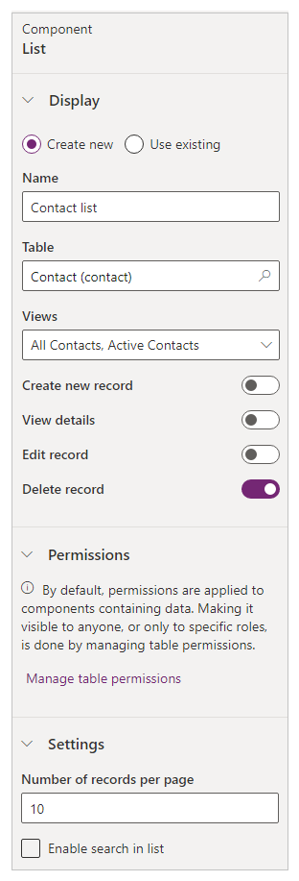

# Add breadcrumb

Breadcrumb shows the links to pages in the hierarchy of the current page. This hierarchy allows users to follow through the trail up to the root page.

To add breadcrumb component to your portal:

1. [Edit the portal](https://docs.microsoft.com/en-us/powerapps/maker/portals/manage-existing-portals#edit) to open it in Power Apps portals Studio.
2. Select the page on which you want to add the component.
3. Select an editable element on the canvas.
4. Select **Components** components icon. from the left side of the screen.
5. Under **Portal components**, select **Breadcrumb**.

# Add custom menu

By default, the menu on the website is created automatically based on the hierarchy of the webpages. It's called the **default** menu. To create a custom menu, you must create the web link set in the Portal Management app. More information: [Manage web links](https://docs.microsoft.com/en-us/powerapps/maker/portals/configure/manage-web-links)

After you create the web link set:

1. [Edit the portal](https://docs.microsoft.com/en-us/powerapps/maker/portals/manage-existing-portals#edit) to open it in Power Apps portals Studio.
2. Select the header component.
3. In the properties on the right side of the screen, select the web link set name from the **Navigation Menu** list.

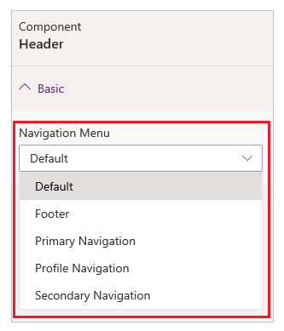

# Use code editor

o view the source of a component on the canvas, select the component, and then select the source code editor icon **</>** in the footer.

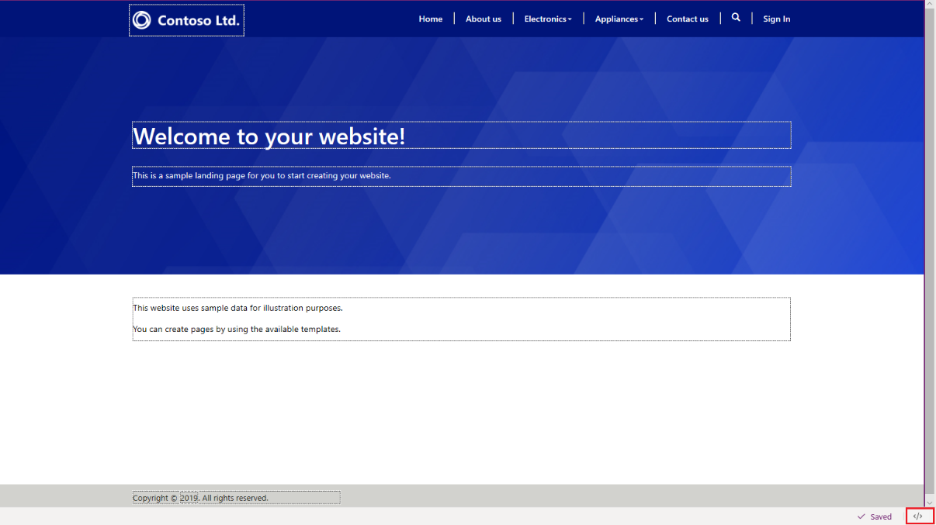

The source code is displayed in the **Code Editor** pane at the bottom of the screen. The changes you made earlier are updated in the source code. To make changes, update the source code and select **Save**. The changes are reflected on the canvas.

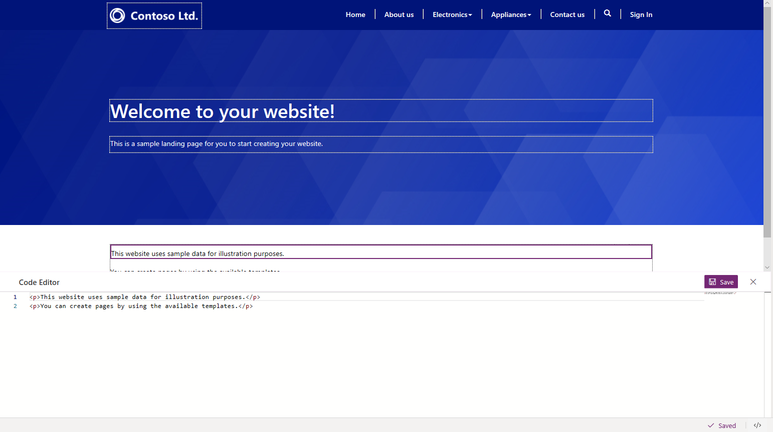

# Add Power BI

You can add a Power BI component on a page to display Power BI dashboards and reports on your portal.

To add a Power BI component to a webpage:

1. [Edit the portal](https://docs.microsoft.com/en-us/powerapps/maker/portals/manage-existing-portals#edit).
2. Select the page you want to add the component to.
3. Select an editable element on the canvas.
4. Select **Components** from the left side of the screen.
5. From the Portal components section, select **Power BI**. The Power BI placeholder is added to the canvas.
6. In the properties pane on the right side of the screen, enter the following information:
   1. **Access type**: From the drop-down, select the appropriate option for your business requirements.

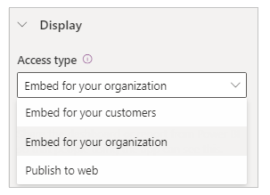

* + 1. **Embed for your customers** - Allows you to securely share the Power BI dashboards or reports to external users without a Power BI license or Azure Active Directory authentication setup. This option uses Power BI Embedded services to integrate Power BI dashboards or reports into your portal.

**Note**

Ensure [**Power BI Embedded service is enabled**](https://docs.microsoft.com/en-us/powerapps/maker/portals/admin/set-up-power-bi-integration#enable-power-bi-embedded-service) and respective Power BI workspaces are selected and shared with the maker or the logged-in user.

* + 1. **Embed for your organization** - Allows you to securely share the Power BI dashboards or reports with Azure Active Directory authenticated users.

**Note**

Ensure you've shared Power BI workspaces with the maker and target portal users.

* + 1. **Publish to web** - Allows you to share Power BI dashboards or reports to anyone on the internet.

For more information about access types, go to [Power BI access type considerations](https://docs.microsoft.com/en-us/powerapps/maker/portals/add-powerbi#power-bi-access-type-considerations).

* 1. **Workspace**: Select the Power BI workspace from the list.
  2. **Select type**: Select type as *Dashboard* or *Report* from the list.

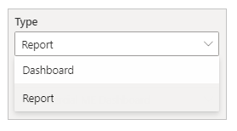

* + 1. **Dashboard** - Allows you to choose a **Dashboard**, and then a **Tile** from the selected dashboard to display on the webpage.
    2. **Report** - Allows you to select a **Report**, and then a **Page** from the report to display on the webpage.
  1. **Apply roles**: If you have defined roles in Power BI and assigned them to reports, you must enter the appropriate roles in this field.

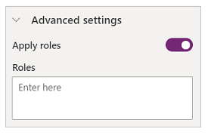

* + 1. You can enter multiple roles separated by a comma (for example, role_1,role_2). For more information on defining roles in Power BI, go to [Row-level security (RLS) with Power BI](https://docs.microsoft.com/en-us/power-bi/service-admin-rls).
    2. This option is only available for the access type **Embed for your customers**.
  1. **Apply filter**: Allows the user to load the report with pre-filtered values. The user can provide a filter condition in the field.

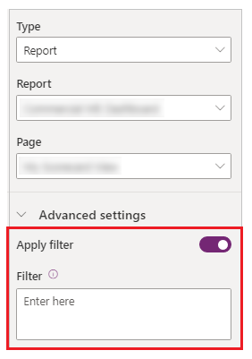

* + 1. The filter parameter must be without the ?filter='' prefix. For example, Table/Field eq 'value'.  
       For more information, go to [filter parameter details](https://docs.microsoft.com/en-us/power-bi/service-url-filters).
    2. This option is only available for **Reports** with access types **Embed for your customers** and **Embed for your organization**.
  1. **Embed code URL**: Enter the embed code URL.

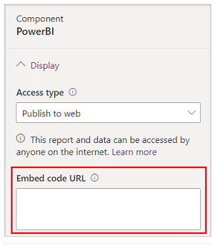

* + 1. To learn how to create and manage embed codes, go to [Publish to web from Power BI](https://docs.microsoft.com/en-us/power-bi/service-publish-to-web)
    2. This option is only available for the access type **Publish to web**.

# Work with templates

The built-in templates are available according to the portal you provision. You can edit the templates by using the code editor. For example, the following built-in templates are available when you provision a Dataverse starter portal:

* Default studio template
* Page with title
* Page with child links

To open a template in code editor:

1. [Edit the portal](https://docs.microsoft.com/en-us/powerapps/maker/portals/manage-existing-portals#edit) to open it in Power Apps portals Studio.
2. Select **Templates** templates icon. from the toolbelt on the left side of the screen. The available templates are displayed.

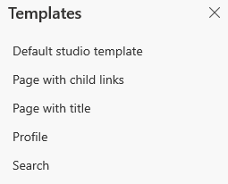

1. Select the required template to open it in the code editor.
2. Edit the code and save the changes.